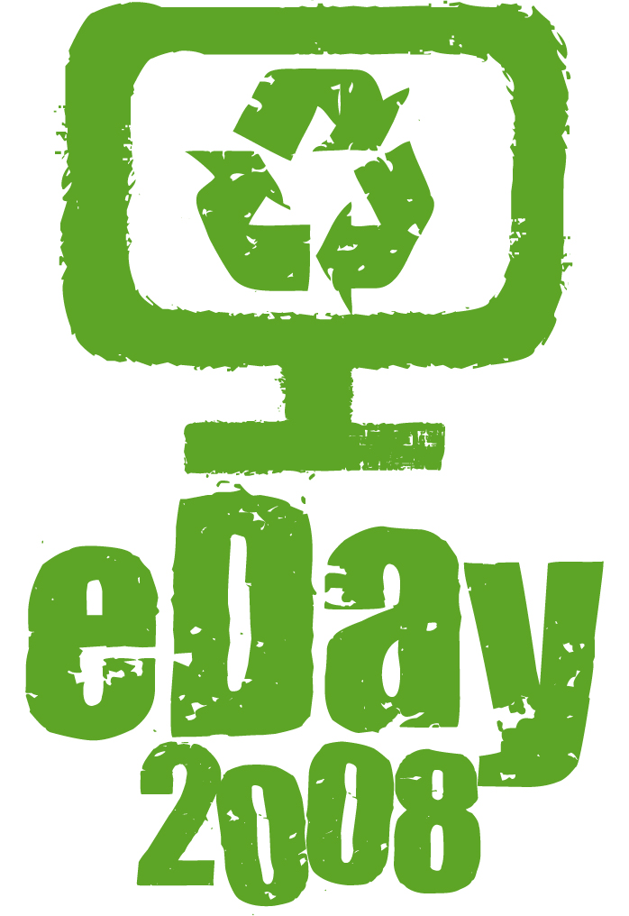
MEDIA RELEASE

FOR IMMEDIATE RELEASE

eDay helps Kiwi schools divert computer waste from landfill

Around 1,500 schools from across the country will be helping to clean up New Zealand’s electronic waste (e-waste) with the launch of School eDay 2008 this month.

School eDay enables schools to safely dispose of unused computer equipment while teaching students about the dangers of disposal of e-waste in landfill and the benefits of recycling.

A recent survey by 2020 Communications Trust titled ICT in Schools Report 2007 found that the most common method for disposing schools’ computers once they are no longer of use is taking them to landfills.

“This prompted us to develop School eDay to provide a convenient mechanism for schools to recycle computer equipment and mobile phones in an environmentally sustainable manner while educating at the same time, making it clear that disposal in landfills is not a sustainable option,” said National organiser Laurence Zwimpfer from the Computer Access NZ Trust (CANZ). By recycling e-waste we are able to recover and reuse valuable materials and this is a key message in our School eDay programme.”

School eDay is part of the national eDay programme which is expected to divert 1,000 tonnes of e-waste from landfill. This year, eDay for the general public will take place on Saturday 4th October in 31 centres across New Zealand and 5th October in Hamilton. Participating eDay regions can be viewed on www.eday.org.nz.

“All equipment collected through School eDay and eDay will be recycled by accredited recyclers who have advised us that over 95% of the materials in a computer can be recovered and re-used,” Mr Zwimpfer said.

Every school in the eDay regions has been provided with educational posters to display around their school and a downloadable schools’ kit that contains fun activities for students to learn about sustainable e-waste disposal, the benefits of recycling and IT energy conservation.

To safely dispose of their unused computer equipment, schools simply complete an online e-waste survey outlining how much e-waste they have and then take it to the free drop-off site during the two weeks before eDay. All participating schools will also go in the draw to win an “e-Waste Eddie” show featuring renowned puppeteer Tony Collis and his eco-friendly buddy e-Waste Eddie.

Mr Zwimpfer said e-waste is globally the fastest growing type of waste being sent to landfill – posing a potential hazard for people, animals and the environment.

“Our aim with eDay is to educate New Zealanders of the problem with dumping electronic waste in landfill and this starts with our youth,” said Mr Zwimpfer. To teach children about the concerns around e-waste, eDay has introduced the e-Waste Eddie show which uses humour, key environmental messages (reduce, reuse, recycle) and visual props to educate and entertain students. “We want to use a range of interventions to educate Kiwi kids about the problems with e-waste in landfills. The puppet show is a new addition to the eDay programme and the response has been fantastic,” he said.

School eDay is an initiative of CANZ and is supported nationally by technology supplier Hewlett-Packard (HP), IT financing company Equico, 2020 Communications Trust and the Ministry of Education.

“We’d like to thank our supporters for partnering with us to help future generations learn about the problems with e-waste. Their support will contribute to the safe recycling of all equipment collected as part of School eDay,” concluded Mr Zwimpfer.

“At HP we are very proud of our commitment to sustainability and the environment,” says Brent Kendrick, General Manager, Personal Systems Group, HP New Zealand. “Being part of School eDay, alongside our education leasing partner Equico, is a great way for us to show that commitment and be involved in an initiative which helps schools to dispose of their electronic waste in an environmentally sound way and also teaches children about the many benefits of recycling.”

“Besides freeing up landfill space, recycling e-waste allows many of the components of computers to be recycled into different material streams so that we don’t rely so heavily on new natural resources and materials in the manufacturing process,” Brent concluded.

Paul Beattie, Managing Director of Equico comments “Equico is pleased to be able to contribute to eDay for schools, and see e-waste as an ever growing problem in the education environment. Leasing through Equico is a positive way of ensuring equipment past its useful life doesn't end up as part of landfill - we take pride in ensuring no ex-lease equipment is disposed of in this manner and our association with HP through the Desktop for Schools programme shows the benefits of recycling as a key message of any leasing programme.”

Schools are advised to visit www.eday.org.nz for more information about School eDay.

/ends (771 words)

The eDay 2008 logo and photographs are available for publication.

CANZ is a not-for-profit trust set up by the 2020 Communications Trust in 2000 with support
from the Ministry of Education to promote the reuse and recycling of computer equipment.
For further information visit www.eday.org.nz or please contact:
Kim Watson  Ph (04) 385 7663  Mob (021) 235 7305  kim@chillimarketing.co.nz | Lara Meredith  Ph (04) 385 7663  Mob (021) 911 221  lara@chillimarketing.co.nz

